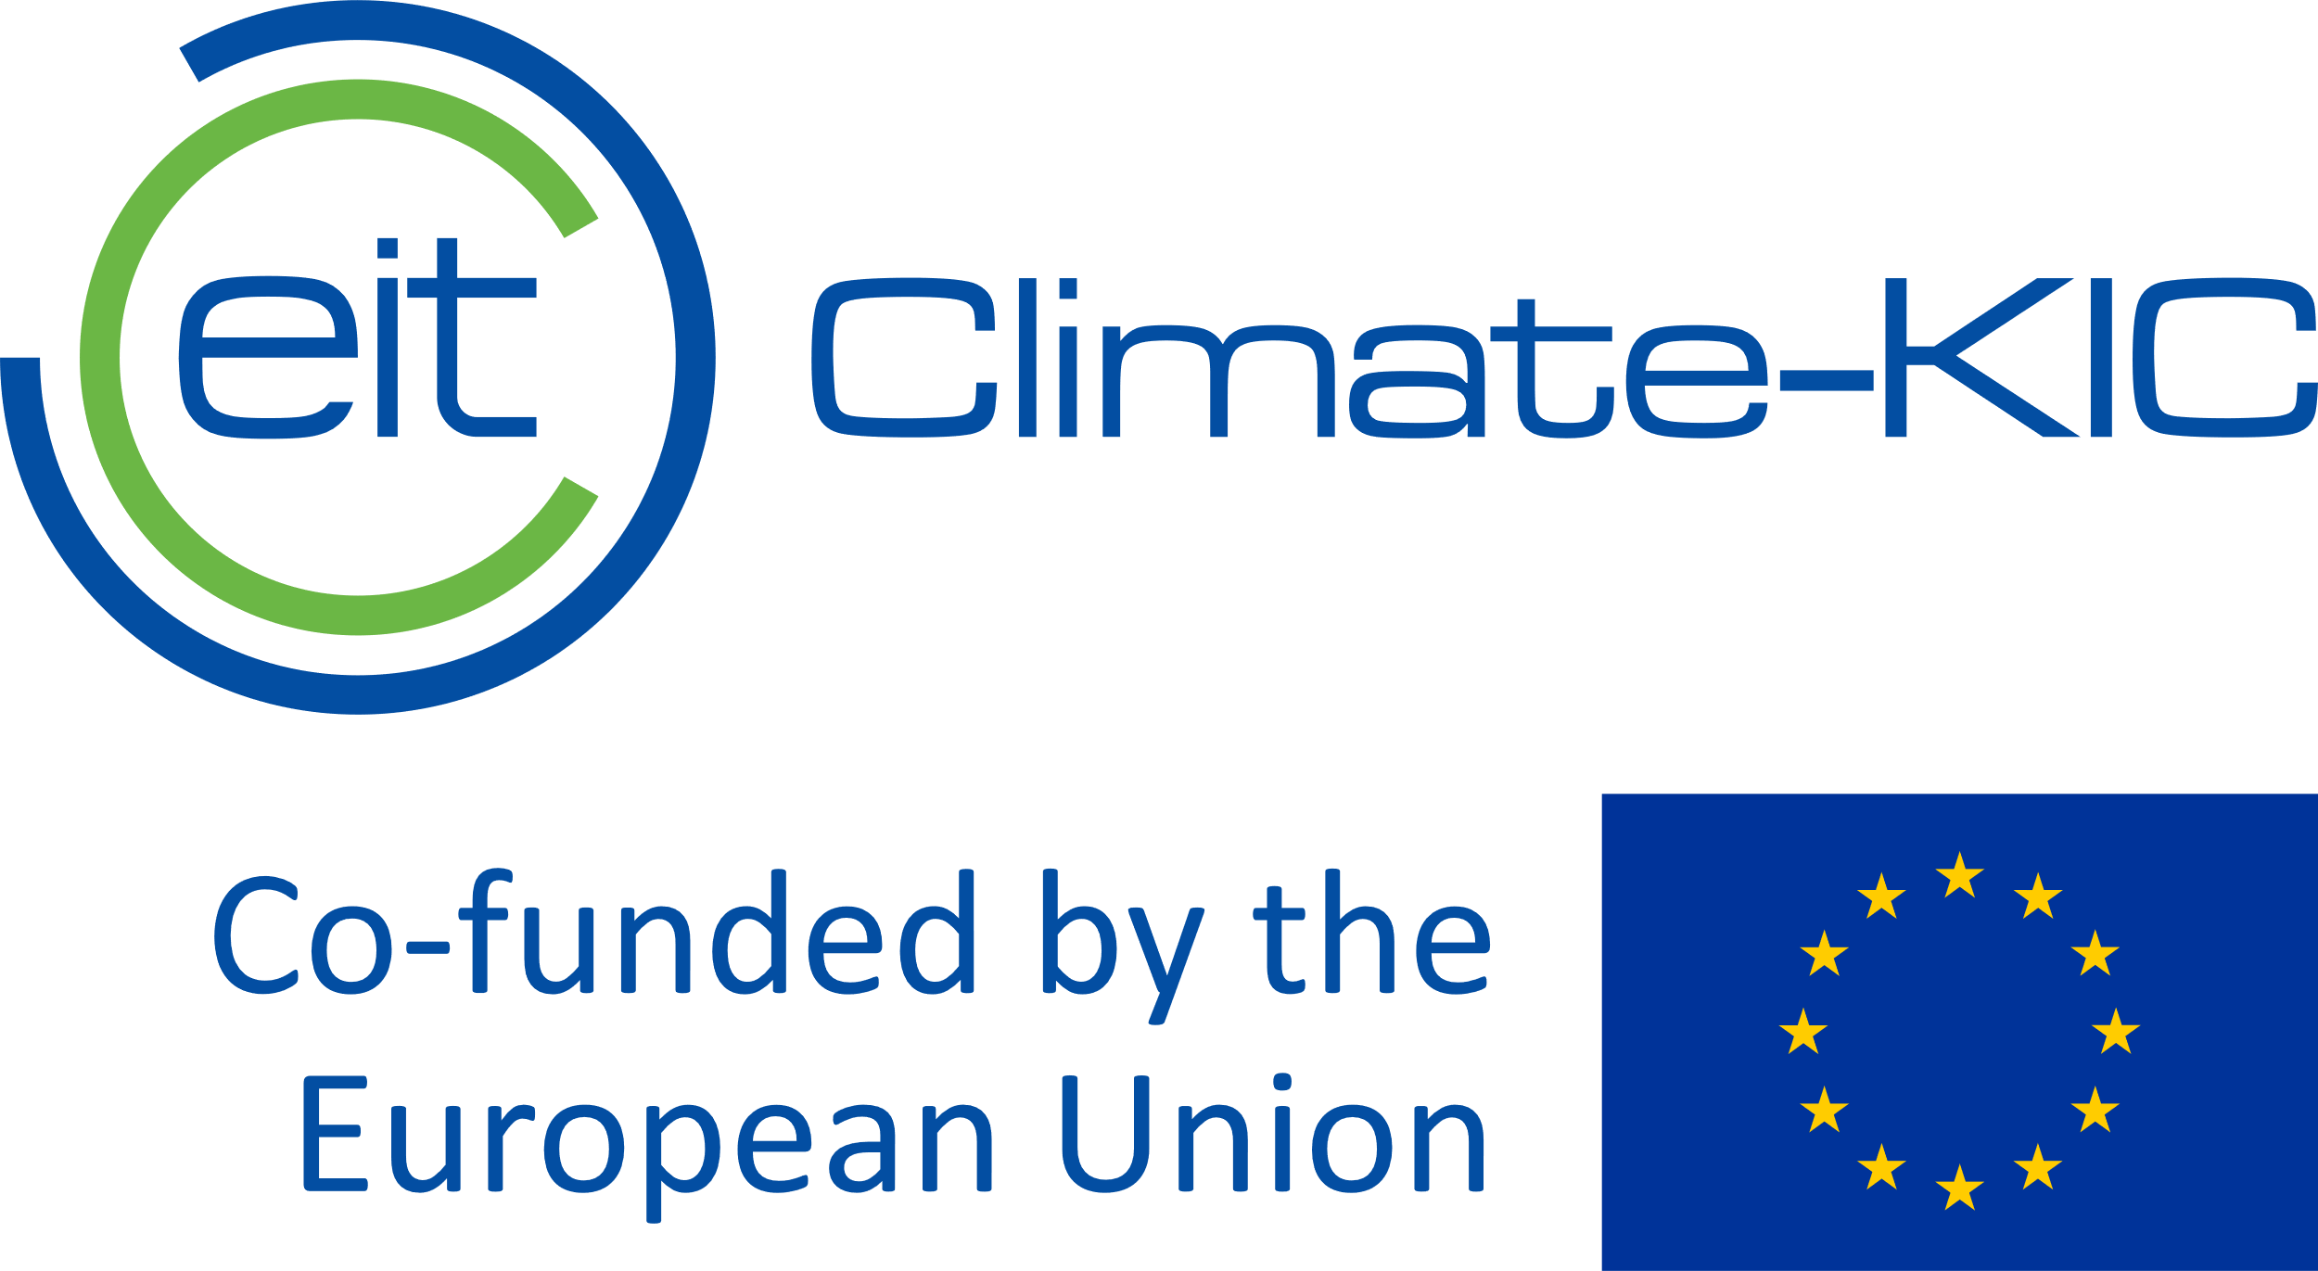
Application form:
Sustainable Cities Mobility Challenge 2024

Please complete the form below in English using a standard font (size 11). Please also upload an estimated project budget (max. two A4 pages). You may also append relevant annexes or supporting visuals e.g. maps, diagrams, photos. In total, the application should not exceed 10 A4 pages.

Full name of town/city (or name of organisation applying on behalf of the city/town):
Physical address of town/city/applicant organisation:
Main contact person for application - full name and job title:
Main contact person: email and telephone number:
Amount of funding requested:

Your project description should respect the limit of 2,000 words (excluding spaces between words) and cover the following:

- Brief description of the mobility challenge/problem you are trying to solve.
- Brief description of the proposed solution(s)
- Briefly identify any potential risks that could affect delivery.
- Implementation timeline
- Anticipated climate/environmental/societal benefits – and how these will be measured.
- Potential for learning and replicability in other cities.
- We anticipate that municipalities will be the main applicants for this call. However, if applicable, please list any other organizations involved in delivering the project (such as NGOs or SMEs).
- Please attach a letter demonstrating the support of the mayor - or other evidence of senior political support/municipal mandate.
- Include an estimated budget (max 2 pages A4), which should include staff costs.
…/

Description of proposed project:
Please provide your word count:
Maximum 2000 words (not counting spaces between words).

List your appendices below:

Please send this completed form (together with budget and relevant appendices) as a pdf document to: sustainablecitiesmobility@climate-kic.org by the deadline: 23.00 CET on Friday, 10 November 2023.

∞End of application form∞

such as Times New Roman, Arial or Calibri

