EIT Community New European Bauhaus initiative

CitIZEn Engagement

Supporting the New European Bauhaus mission of integrating innovation, creativity and design to improve citizens’ quality of life while respecting our planet, the European Institute of Innovation and Technology (EIT) is mobilising its pan-European ecosystem to spur innovation through the EIT Community New European Bauhaus initiative.

18 Citizen Engagement projects from 12 countries have been selected from two programmes launched by the EIT Community: New European Bauhaus Citizen Engagement Programme aimed at identifying and co-creating community solutions with citizens and New European Bauhaus Co-creation of Public Spaces aimed at resolving challenges and redesigning public spaces in cities, semi-urban and rural area and

Each project will receive between EUR 15 000 and EUR 45 000 to support the testing and scaling of their innovations.

Awarded projects:
New European Bauhaus Co-creation of Public Spaces
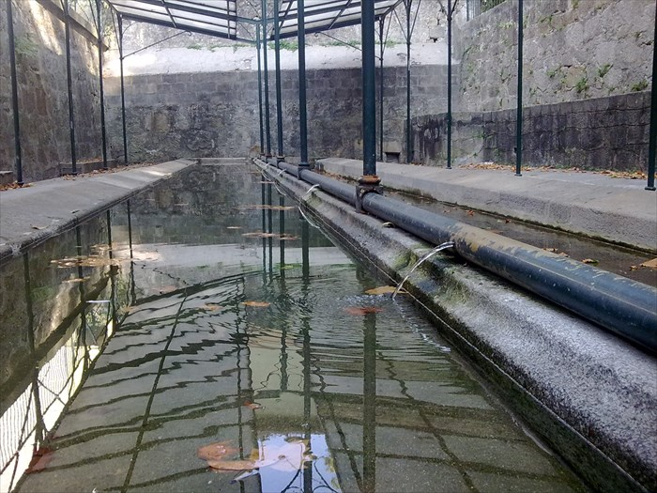
Porto Think Tank (Portugal; supported by EIT Climate-KIC)
Focusing on Porto’s 24 Lavadouros (communal wash houses), this project will transform these architectural artifacts, historically linked to women, through consultation with local communities to explore new ways of sustainable use.
Greenovate (Greece; supported by EIT Urban Mobility)
This project will revitalise the centre of Kozani using sustainable materials to transform green spaces for children and seniors. By engaging local businesses and young students in not only the planning and preparation phase, the project aims to preserve green spaces and foster a sense of belonging.
Imagine your city: utilizing urban co-designing and NEB principles to make stronger communities
(Slovakia; supported by EIT Climate-KIC)
This project aims to bring together local citizens of Kosice and newly arrived refugees from Ukraine to reimagine public space around the temporary refugee shelters. This will be done through artistic means, such as objects, murals and video mapping, and the project will aim to understand how the process can be scaled for other cities.

Open Nature (Spain; supported by EIT Urban Mobility)
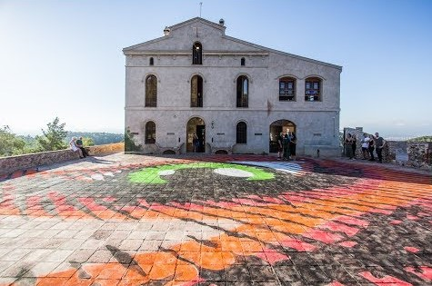
Open Nature will work with the Collserola Natural Park, central to the Metropolitan Area of Barcelona, to identify sites in need of ecologic and aesthetic remediation and then install elements inviting public engagement while promoting sustainability. The installations will be co-designed by students from surrounding urban schools, with limited access to nature, offering an inclusive experience to learn from the world around them.
ASD-Publics (Spain; supported by EIT Climate-KIC)
ASD-publics will aim to explore nature-based solutions to improve playing areas for children with autism and their families. The project will pilot co-creation with the Autism Spectrum Disorder (ASD) community to understand how spaces can be changed to create a more inclusive and multi-sensorial experience.
Recharging recovery: co-creating public space in healthcare (Slovenia; supported by EIT Urban Mobility)
Focusing on green space at the heart of Ljubljana’s clinical centre, this project will follow a co-design process with patients and medical personnel to transform the space to become useful for patient recovery and the well-being of medical staff. The data gathered through these activities will be used as evidence in the upcoming climate adaptation strategy for the wider municipality of Ljubljana.
Remedspace (France; supported by EIT Food)
Based in Marseille, REMEDSPACE aims to help the local council restore heritage buildings by removing pollution through nature-based solutions. The project will aim to inform and support citizens, professionals and public entities about the nature-based approach to cleaning up these areas and bringing in an artistic approach to redesign the spaces for better public use.
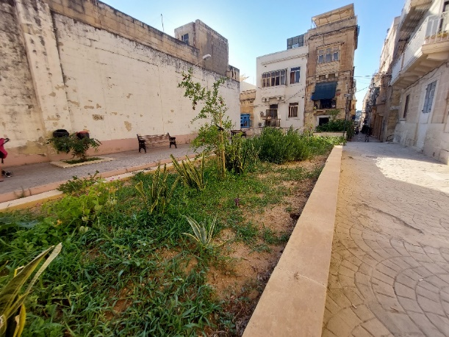
Recreate (Malta; supported by EIT Food)
Focusing on the locality of Senglea, this project will work with local citizens to transform unused public spaces through nature-based solutions, such as gardening, and help to create strong relationships between active citizen groups and the local council.

New European Bauhaus Citizen Engagement Programme

CONNECT, Community for Timisoara (Romania; supported by EIT Climate-KIC)
Working across Timisoara, this project will aim to integrate Ukrainian refugees, particularly women, into the community by raising awareness of the role foreign people have played in the development of the city. This will be explored through gatherings that take an artistic and social lens, using sustainable materials to connect art to history and to build bonds between communities.
ProdMeSe, Modular Refugee Settlement Project (Ukraine, Poland; supported by EIT Urban Mobility)
The settlement project, based on the outskirts of Lviv, will create a place to live for people forced to leave their homes as a result of the war in Ukraine and will do so through a co-creation process. Beginning with identifying needs, the ideas will be solidified through participatory activities, bringing in architects, environmental and construction experts to work with the refugees to build a home that matches their needs, as well as a housing complex that serves both the settling community and those already in the city.
H4H, Horticulture for the homeless (Ireland; supported by EIT Food)
Focusing on people in services who are homeless or at risk of being homeless in and around Limerick City, the project will install polytunnels for the two emergency accommodation facilities, as well as engaging qualified horticulturalists to teach residents about horticulture, growing food and sustainability.
Building Sharing Community (Slovenia; supported by EIT Urban Mobility)
This initiative will bring the idea of Library of Things (LOT), a non-profit that encourages its users to rent items they would normally buy, to the residents of Novo Brdo. The initiative aims to educate people about the environmental and social benefits of a shared economy, as well as creating relationships across neighbourhoods.
STATION SOFIA – New Greenways for Old Railway (Bulgaria; supported by EIT Urban Mobility)
STATION SOFIA will demonstrate the revitalisation potential of the unused railway territories and buildings of Stochna Gara and to guide their sustainable transformation to an inclusive, innovative and multifunctional urban space. This will be achieved through a holistic discussion around a common vision for the future use of this post-industrial heritage, engaging neighbours, institutional stakeholders and diverse experts.
Harbor Highlight Actions: reconnecting citizens with the beauty of the river (France; Supported by EIT Climate)
Harbor will utilise summer workshops and learning explorations to design and animate shipyard districts, interweaving art and innovation and exploring the shared heritage of the Seine in Paris. The project will prioritise vulnerable communities, such as younger people and the elderly, as well as directly connecting citizens to professionals and policymakers.
SOCIAL4FOOD (Italy; supported by EIT Food)
Through a series of social farming activities, SOCIAL4FOOD aims to help the Town of Arsoli to empower teenagers, including young immigrants, to become involved in collaboratively farming and cooking. The project will also highlight cultural artefacts, including heritage and cuisine with a special focus on an ancient bean associated to the town named, “fagiolina arsolana”.
FOODLIE (Latvia; Supported by EIT Food)
Bringing together an interdisciplinary group of artists, experts, students and gardeners, this project will aim to bring to life to local heritage sites. The project will use gardening, traditional artworks and prototypes that educate the public of the ‘old ways’, whilst offering new ways for sustainable food production.

ElTra: Elderly on Track (Spain; Supported by EIT Urban Mobility)
The EITra project aims to enhance mobility within seniors’ networks, improving their physical and mental health, as well as fostering social inclusion. This will be done by identifying suitable walking routes for the elderly population within the Rubí municipality (Barcelona) and testing the participants experience of recreating with nature and other citizens in their communities.
Adáma: community togetherness for a sustainable future (Greece; Supported by EIT Climate-KIC)
Implemented in Elusis, Greece, Adáma will work with citizens to understand local issues through participatory methods and ‘co-envision’ sustainable solutions to these problems. The project will bring in expertise, such as artists and cultural professionals, as well as connecting active citizens and local government stakeholders.

