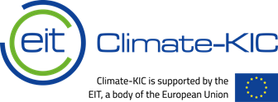

Procurement Advertisement

Contract Details
Title | Blended learning team 2020 procurement
Short description | EIT Climate-KIC are seeking to appoint a panel of recruitment agencies to manage and appoint relevant contractors/consultants to assist with blended learning delivery (e.g. learning content, learning journeys production, etc).
Proposed type of contract | - Framework agreement
Type of process | - Request for Quotation
Legal entity | - Climate-KIC Holding B.V.
Contract duration | 6 months plus option to renew for a further 3 months at EIT Climate-KIC’s discretion
Details of goods/services to be provided | The agency will take responsibility for identifying contractors, payroll management, contract management and contractor compliance. It is anticipated that the services are provided on a commission-based model, whereby the agency receives a percentage of the actual services consumed.

Timeline
Deadline for receipt of expressions of interest | 08.10.2020
Date EIT Climate-KIC will send bid documents | 09.10.2020
Deadline for receipt of proposals | 23.10.2020
Proposal must be valid for | minimum of 6 months

Contact Details to register your Expression of Interest
Contact person | Piret Liv Stern Dahl
Contact person’s role | Learning Technologies Strategy Developer
Email | Piret.sterndahl@climate-kic.org

