MTH Ph.D. Summer School opens for applications
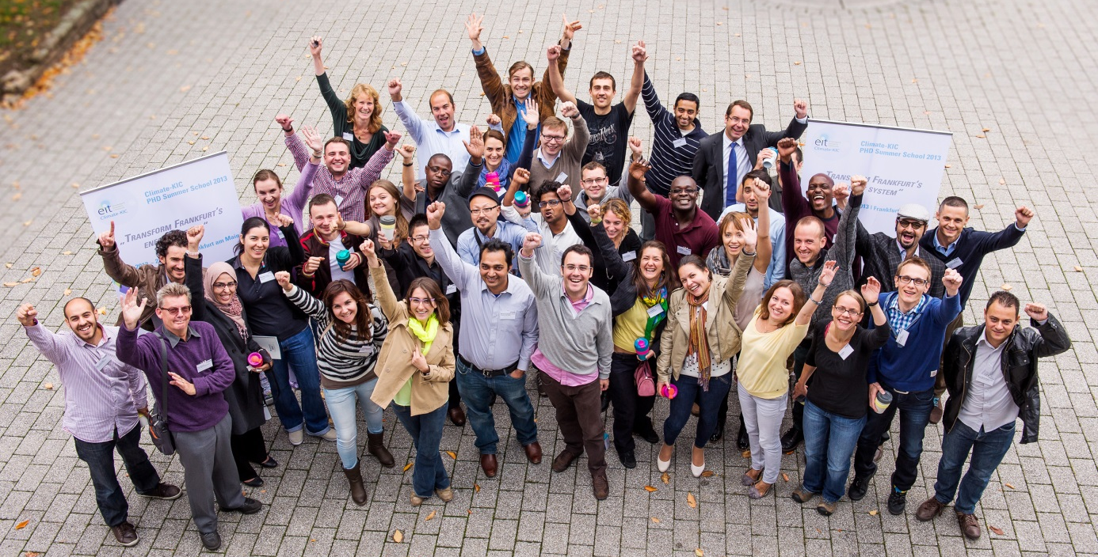
  - Participants of the last year’s MTH PhD. Summer School in Frankfurt
12 May 2014

Interested in the energy transition, climate change, user engagement and the role of the financial industry? The Climate-KIC Ph.D. Summer School ‘Energy Transition in Frankfurt: Overcoming Barriers to Change’ has opened for applications.
This Climate-KIC summer course will focus in general on the formation of societal transformation processes and exemplary on the local energy transition in Frankfurt am Main. Dealing with the different change barriers of this transformation is in the special interest of the upcoming Summer School that is organised by the Provadis School in close collaboration with the Climate-KIC partners City of Frankfurt and TU Darmstadt as well as Goethe University Frankfurt.
The two-week intensive programme will take place between 1 and 12 September 2014 in Frankfurt am Main, Germany, and will bring together experts from across Europe.
Interested candidates are invited to apply by 8 June 2014.

Climate Finance, System Experiments and Unser Engagement
Participants will learn and apply methods of transition thinking to the following three focus topics:
  - New financial mechanisms for climate change and the role of the financial industry on the path to a Green Transition
  - System experiments on urban district scale, examples from Frankfurt
  - User involvement and citizen participation for the energy transition
Subject of the Summer School is to prepare proposals for implementing the energy transition in the city of Frankfurt. During the 2-week Summer School doctoral students develop concepts (so-called "assignment") for the concrete implementation of the urban energy transition in teams. These assignments are then presented on the last day of the Summer School to an international jury. The results are made available to the city and serve as ideas and suggestions for new projects and methods within the framework of the Masterplan “100% Klimaschutz”.
Making Transitions Happen is one of Climate-KIC’s strategic challenges.

What you can expect
The participants of the Summer School hear speeches by national and international scientists to various theoretical approaches regarding the topic of the Summer School. In addition, practitioners from industry and politics teach the students their application-oriented knowledge. The knowledge transfer takes place not only through lectures, but is made up of elements such as excursions, panel discussions and workshops, so that an interactive discussion of the problem is suggested.
The Climate-KIC PhD summer school so is a transdisciplinary and project-based approach that aims to contribute - using a multi-perspective analysis - to better understand climate-related transformation processes at city level and makes them happen.

Who can join?
In addition to students from the Climate-KIC PhD programme, for whom participating in the two -week thematic Summer School in their second or third year of study is mandatory, other interested PhD students can participate. The Summer School offers places for 30 to a maximum of 40 graduate students and is completely free of charge for participants (travel costs to and from Frankfurt not included). In the last year, 36 doctoral students from 20 different European universities participated (10 of them Climate-KIC PhD students). The group was composed of 23 different nationalities and was characterized by high transdisciplinarity: Among others, students of the disciplines of engineering, environmental science, economics, architecture and urban planning came together in the Summer School 2013.

Applications
A full course description and information on how to apply is available here.

Also see:
- Ph.D. Summer School 2014: Energy Transition in Frankfurt

Energy Transition in Frankfurt: Overcoming Barriers to Change
- PhD Summer School 2013: Make Frankfurt am Main carbon free by 2050
- Climate-KIC PhD Summer School 2013: Frankfurt’s vision
- Climate-KIC PhD Summer School 2013: The transition to a green and low-carbon economy is essential
- Transforming Frankfurt into a carbon-neutral city

